## Task 01: Export Geo Location Reference

CREATE TABLESPACE sb_mbackup DATAFILE 'DATA1.dbf' SIZE 100 M LOGGING;

GRANT CREATE SESSION TO sb_mbackup;

CREATE USER sb_mbackup IDENTIFIED BY pass DEFAULT TABLESPACE sb_mbackup QUOTA UNLIMITED ON sb_mbackup;

GRANT SELECT ON u_dw_references.cu_geo_regions TO sb_mbackup;

GRANT SELECT ON u_dw_references.cu_geo_parts TO sb_mbackup;

GRANT SELECT ON u_dw_references.cu_geo_systems TO sb_mbackup;

GRANT SELECT ON u_dw_references.cu_cntr_group_systems TO sb_mbackup;

GRANT SELECT ON u_dw_references.cu_cntr_groups TO sb_mbackup;

GRANT SELECT ON u_dw_references.cu_cntr_sub_groups TO sb_mbackup;

GRANT SELECT ON u_dw_references.cu_countries TO sb_mbackup;

GRANT SELECT ON u_dw_references.w_geo_object_links TO sb_mbackup;

GRANT CREATE TABLE TO sb_mbackup;

CREATE TABLE exp_locations AS

SELECT country_geo_id

, cntr.country_id

, cntr.country_code_a3

, cntr.region_desc AS country_desc

, NVL ( g_region_id, -99 ) AS region_geo_id

, NVL ( reg.src_continent_id, -99 ) AS region_id

, NVL ( reg.region_code, 'n.d.' ) AS region_code

, NVL ( reg.region_desc, 'n.d.' ) AS region_desc

, NVL ( g_part_id, -99 ) AS part_geo_id

, NVL ( part.part_id, -99 ) AS part_id

, NVL ( part.part_code, 'n.d.' ) AS part_code

, NVL ( part.part_desc, 'n.d.' ) AS part_desc

, NVL ( g_system_id, -99 ) AS geo_system_geo_id

, NVL ( g_sys.src_geo_system_id, -99 ) AS geo_system_id

, NVL ( g_sys.geo_system_code, 'n.d.' ) AS geo_system_code

, NVL ( g_sys.geo_system_desc, 'n.d.' ) AS geo_system_desc

, NVL ( grp_sub_gr, -99 ) AS sub_group_geo_id

, NVL ( sub_grp.sub_group_id, -99 ) AS sub_group_id

, NVL ( sub_grp.sub_group_code, 'n.d.' ) AS sub_group_code

, NVL ( sub_grp.sub_group_desc, 'n.d.' ) AS sub_group_desc

, NVL ( grp_group, -99 ) AS group_geo_id

, NVL ( grp.GROUP_ID, -99 ) AS GROUP_ID

, NVL ( grp.group_code, 'n.d.' ) AS group_code

, NVL ( grp.group_desc, 'n.d.' ) AS group_desc

, NVL ( grp_sys, -99 ) AS grp_system_geo_id

, NVL ( grp_sys.grp_system_id, -99 ) AS grp_system_id

, NVL ( grp_sys.grp_system_code, 'n.d.' ) AS grp_system_code

, NVL ( grp_sys.grp_system_desc, 'n.d.' ) AS grp_system_desc

FROM ( SELECT parent_geo_id AS geo_id

, CONNECT_BY_ROOT child_geo_id AS country_geo_id

, link_type_id

FROM u_dw_references.w_geo_object_links

START WITH child_geo_id IN (SELECT geo_id

FROM u_dw_references.cu_countries)

CONNECT BY PRIOR parent_geo_id = child_geo_id) PIVOT (SUM ( geo_id )

FOR link_type_id

IN (1 AS g_system_id

, 2 AS g_part_id

, 3 AS g_region_id

, 4 AS grp_sys

, 5 AS grp_group

, 6 AS grp_sub_gr)) t1

LEFT OUTER JOIN u_dw_references.cu_countries cntr

ON ( cntr.geo_id = t1.country_geo_id )

LEFT OUTER JOIN u_dw_references.cu_geo_regions reg

ON ( reg.geo_id = t1.g_region_id )

LEFT OUTER JOIN u_dw_references.cu_geo_parts part

ON ( part.geo_id = t1.g_part_id )

LEFT OUTER JOIN u_dw_references.cu_geo_systems g_sys

ON ( g_sys.geo_id = t1.g_system_id )

LEFT OUTER JOIN u_dw_references.cu_cntr_group_systems grp_sys

ON ( grp_sys.geo_id = t1.grp_sys )

LEFT OUTER JOIN u_dw_references.cu_cntr_groups grp

ON ( grp.geo_id = t1.grp_group )

LEFT OUTER JOIN u_dw_references.cu_cntr_sub_groups sub_grp

ON ( sub_grp.geo_id = t1.grp_sub_gr );

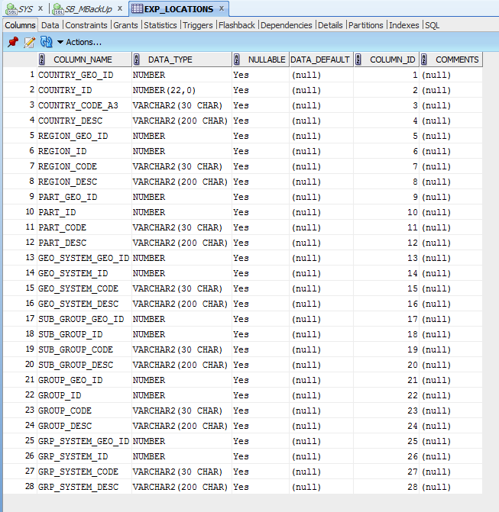

**Required points:**

* Add Additional Columns to table:
  + Geo_id types: Branch, ROOT, Leaf
  + Count of childs of Branch or Root, for Leafs this Field you have fill by NULL
  + Full path of Dependencies by Example: ROOT -> BRANCH -> BRANCH -> LEAF
* SELECT LPAD ( ' '
* , LEVEL * 2 - 1
* , ' ' )
* || child_geo_id
* AS geo_id
* , parent_geo_id
* || SYS_CONNECT_BY_PATH ( child_geo_id
* , '-' )
* AS PATH
* , link_type_id
* , CASE
* WHEN LEVEL = 1 THEN 'ROOT'
* WHEN CONNECT_BY_ISLEAF = 1 THEN 'LEAF'
* ELSE 'BRANCH'
* END
* AS "LEVEL"
* , CASE
* WHEN CONNECT_BY_ISLEAF = 1 THEN
* NULL
* ELSE
* ( SELECT COUNT ( child_geo_id )
* FROM u_dw_references.t_geo_object_links
* START WITH parent_geo_id = t1.child_geo_id
* CONNECT BY PRIOR child_geo_id = parent_geo_id )
* END
* count_of_childs
* FROM (SELECT *
* FROM u_dw_references.t_geo_object_links
* UNION
* SELECT NULL
* , geo_id
* , NULL
* FROM u_dw_references.lc_cntr_group_systems
* UNION
* SELECT NULL
* , geo_id
* , NULL
* FROM u_dw_references.lc_geo_systems) t1
* START WITH parent_geo_id IS NULL
* CONNECT BY PRIOR child_geo_id = parent_geo_id
* ORDER SIBLINGS BY child_geo_id;

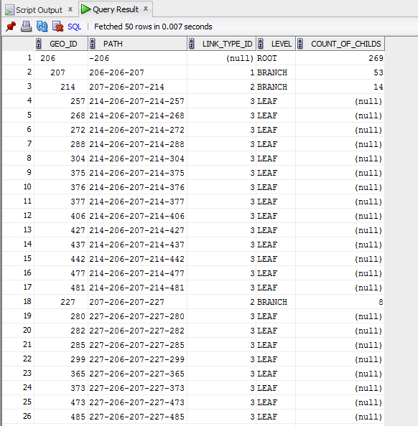

## Task 02: Analyse Business hierarch Reference Analyses

**The Main Task** is to create hierarch analyses of any Dimension, according yours Solution Proposal and DWH Solution Concept from Module 6. Introduction to DWH

**Required points:**

* Create Denormalized table data using CONNENT_BY
* Use START WITH Clause
* Use CONNECT_BY_ROOT to analyses any Branch levels
* Analyze Main Root Branch, and 2 Sub Branches

SELECT country_geo_id

, cntr.country_id

, cntr.country_code_a3

, cntr.region_desc AS country_desc

, NVL ( g_region_id, -99 ) AS region_geo_id

, NVL ( reg.src_continent_id, -99 ) AS region_id

, NVL ( reg.region_code, 'n.d.' ) AS region_code

, NVL ( reg.region_desc, 'n.d.' ) AS region_desc

, NVL ( g_part_id, -99 ) AS part_geo_id

, NVL ( part.part_id, -99 ) AS part_id

, NVL ( part.part_code, 'n.d.' ) AS part_code

, NVL ( part.part_desc, 'n.d.' ) AS part_desc

FROM ( SELECT parent_geo_id AS geo_id

, CONNECT_BY_ROOT child_geo_id AS country_geo_id

, link_type_id

FROM u_dw_references.w_geo_object_links

START WITH child_geo_id IN (SELECT geo_id

FROM u_dw_references.cu_countries)

CONNECT BY PRIOR parent_geo_id = child_geo_id) PIVOT (SUM ( geo_id )

FOR link_type_id

IN (2 AS g_part_id, 3 AS g_region_id)) t1

LEFT OUTER JOIN u_dw_references.cu_countries cntr

ON ( cntr.geo_id = t1.country_geo_id )

LEFT OUTER JOIN u_dw_references.cu_geo_regions reg

ON ( reg.geo_id = t1.g_region_id )

LEFT OUTER JOIN u_dw_references.cu_geo_parts part

ON ( part.geo_id = t1.g_part_id );